SECTION 1: Identification

1.1. Product identifier
Product name | : | Soft Set
Product code | : | SS04, SS08 SS16

1.2. Recommended use and restrictions on use
Recommended uses and restrictions | : | Pipe Thread Sealant

1.3. Supplier
Manufacturer  Fedpro an FPC International Company  44128 Cleveland OH - USA  T 1-800-846-7325 | Distributor  Add the name, address and tel. number of the Canadian manufacturer or importer who operates in Canada

1.4. Emergency telephone number
Emergency number | : | Chemtrec 1-800-424-9300

SECTION 2: Hazard identification

2.1. Classification of the substance or mixture

Classification (GHS CA)
Flam. Liq. 3 | H226 | Flammable liquid and vapour.
Eye Irrit. 2A | H319 | Causes serious eye irritation.
STOT RE 1 | H372 | Causes damage to organs through prolonged or repeated exposure.

2.2. GHS Label elements, including precautionary statements

GHS-CA labelling
Hazard pictograms (GHS-CA) | : | 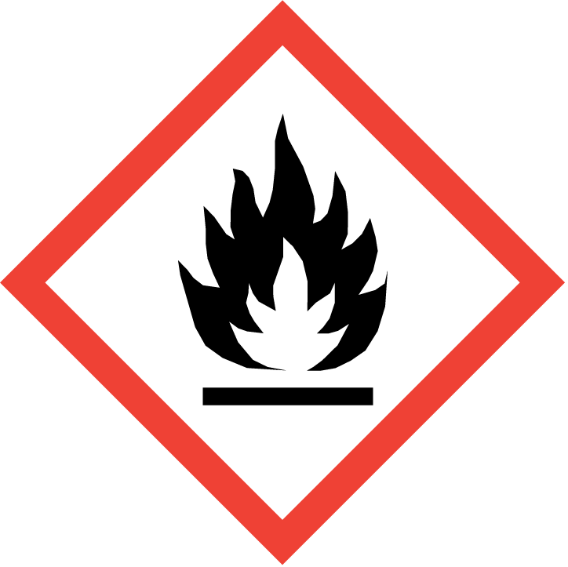 |  | 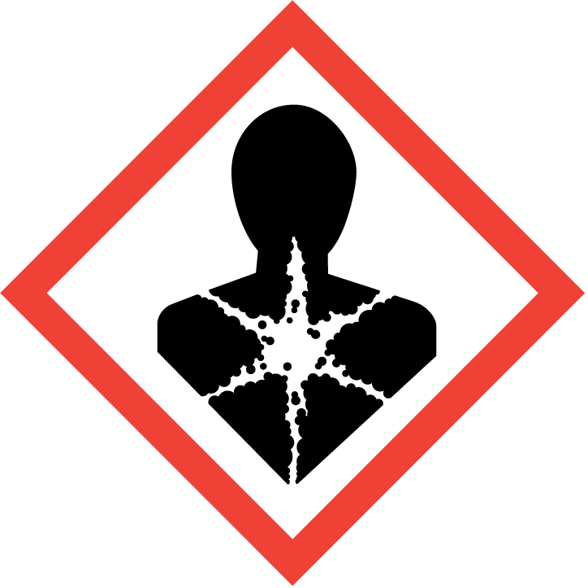
Signal word (GHS CA) | : | Danger

Hazard statements (GHS-CA) | : | H226 - Flammable liquid and vapour.  H319 - Causes serious eye irritation.  H372 - Causes damage to organs through prolonged or repeated exposure.
Precautionary statements (GHS-CA) | : | P210 - Keep away from heat, hot surfaces, sparks, open flames and other ignition sources. No smoking.  P233 - Keep container tightly closed.  P240 - Ground/bond container and receiving equipment.  P241 - Use explosion-proof electrical/ventilating/lighting equipment.  P242 - Use only non-sparking tools.  P243 - Take action to prevent static discharges.  P260 - Do not breathe dust/fume/gas/mist/vapours/spray.  P264 - Wash hands, forearms and face thoroughly after handling.  P270 - Do not eat, drink or smoke when using this product  P280 - Wear protective gloves/protective clothing/eye protection/face protection.  P314 - Get medical advice/attention if you feel unwell.  P303+P361+P353 - IF ON SKIN (or hair): Take off immediately all contaminated clothing. Rinse skin with water .  P305+P351+P338 - IF IN EYES: Rinse cautiously with water for several minutes. Remove contact lenses, if present and easy to do. Continue rinsing.  P337+P313 - If eye irritation persists: Get medical advice/attention.  P403+P235 - Store in a well-ventilated place. Keep cool  P501 - Dispose of contents/container to hazardous or special waste collection point, in accordance with local, regional, national and/or international regulation.

2.3. Other hazards
No additional information available

2.4. Unknown acute toxicity (GHS CA)
Not applicable

SECTION 3: Composition/information on ingredients

3.1. Substances
Not applicable

3.2. Mixtures
Name | Chemical name / Synonyms | Product identifier | %
2-Butoxyethanol | 2-Butoxy-1-ethanol / Butoxyethanol / Ethanol, 2-butoxy- / Ethylene glycol monobutyl ether / Ethylene glycol n-butyl ether / Hydroxyethyl butyl ether / Ethylene glycol butyl ether / 2-Butoxyethan-1-ol / Ethylene glycol mono-n-butyl ether / 2-n-Butoxyethanol / Butyl glycol / BUTOXYETHANOL / EGBE / EGMBE / Butoxyethanol, 2- / Butyl Cellosolve / Monobutyl ether of ethyleneglycol | CAS-No.: 111-76-2 | 3 - 7
Isopropyl alcohol | 2-Hydroxypropane / 2-Propyl alcohol / 2-Propanol / Isopropanol / Propan-2-ol / ISOPROPYL ALCOHOL / Propanol, 2- / Isopropylic alcohol | CAS-No.: 67-63-0 | 3 - 7

Comments | : | *Chemical name, CAS number and/or exact concentration have been withheld as a trade secret

SECTION 4: First-aid measures

4.1. Description of first aid measures
First-aid measures after inhalation | : | If breathing is difficult, remove victim to fresh air and keep at rest in a position comfortable for breathing. Get medical advice/attention if you feel unwell.
First-aid measures after skin contact | : | If on skin (or hair): Take off immediately all contaminated clothing. Rinse skin with water/shower. Wash clothing before re-using. Get medical attention if irritation develops and persists.
First-aid measures after eye contact | : | IF IN EYES: Rinse cautiously with water for several minutes. Remove contact lenses, if present and easy to do. Continue rinsing. If eye irritation persists: Get medical advice/attention.
First-aid measures after ingestion | : | Do not induce vomiting without medical advice. Never give anything by mouth to an unconscious person. Get medical advice/attention if you feel unwell.

4.2. Most important symptoms and effects (acute and delayed)
Symptoms/effects after inhalation | : | May cause irritation to the respiratory tract.
Symptoms/effects after skin contact | : | May cause skin irritation. Repeated exposure may cause skin dryness or cracking.
Symptoms/effects after eye contact | : | Causes serious eye irritation. Symptoms may include discomfort or pain, excess blinking and tear production, with marked redness and swelling of the conjunctiva.
Symptoms/effects after ingestion | : | May be harmful if swallowed. May cause gastrointestinal irritation, nausea, vomiting and diarrhea.

4.3. Immediate medical attention and special treatment, if necessary
Other medical advice or treatment | : | Symptoms may be delayed. In case of accident or if you feel unwell, seek medical advice immediately (show the label where possible).

SECTION 5: Fire-fighting measures

5.1. Suitable extinguishing media
Suitable extinguishing media | : | Foam. Carbon dioxide (CO2). Dry chemical. Water fog.

5.2. Unsuitable extinguishing media
Unsuitable extinguishing media | : | None known.

5.3. Specific hazards arising from the hazardous product
Fire hazard | : | Products of combustion may include, and are not limited to: oxides of carbon. Flammable liquid and vapour.
Explosion hazard | : | May form flammable/explosive vapour-air mixture.

5.4. Special protective equipment and precautions for fire-fighters
Protection during firefighting | : | Keep upwind of fire. Wear full fire fighting turn-out gear (full Bunker gear) and respiratory protection (SCBA).

SECTION 6: Accidental release measures

6.1. Personal precautions, protective equipment and emergency procedures
General measures | : | Use personal protection recommended in Section 8. Isolate the hazard area and deny entry to unnecessary and unprotected personnel. Use special care to avoid static electric charges. Remove all sources of ignition. Use only non-sparking tools.

6.2. Methods and materials for containment and cleaning up
For containment | : | Remove ignition sources. Contain and/or absorb spill with inert material (e.g. sand, vermiculite), then place in a suitable container. Do not flush to sewer or allow to enter waterways. Use appropriate Personal Protective Equipment (PPE).
Methods for cleaning up | : | Sweep or shovel spills into appropriate container for disposal. Provide ventilation.

6.3. Reference to other sections
For further information refer to section 8: "Exposure controls/personal protection"

SECTION 7: Handling and storage

7.1. Precautions for safe handling
Precautions for safe handling | : | Avoid contact with skin and eyes. Do not breathe dust, fume, gas, mist, spray, vapours. Do not swallow. Keep away from heat, hot surfaces, sparks, open flames and other ignition sources. No smoking. Ground/bond container and receiving equipment. Use explosion-proof electrical/ventilating/lighting equipment. Take precautionary measures against static discharge. Use only non-sparking tools. Handle and open container with care. When using do not eat, drink or smoke.
Hygiene measures | : | Take off immediately all contaminated clothing and wash it before reuse. Wash hands, forearms and face thoroughly after handling. Contaminated work clothing should not be allowed out of the workplace.
Additional hazards when processed | : | Handle empty containers with care because residual vapours are flammable.

7.2. Conditions for safe storage, including any incompatibilities
Technical measures | : | Proper grounding procedures to avoid static electricity should be followed.
Storage conditions | : | Keep out of the reach of children. Store tightly closed in a dry, cool and well-ventilated place. Keep away from heat, flames and sparks.

SECTION 8: Exposure controls/personal protection

8.1. Control parameters

2-Butoxyethanol (111-76-2)
USA - ACGIH - Occupational Exposure Limits
Local name | 2-Butoxyethanol (EGBE)
ACGIH OEL TWA [ppm] | 20 ppm
Remark (ACGIH) | TLV® Basis: Eye & URT irr. Notations: A3 (Confirmed Animal Carcinogen with Unknown Relevance to Humans); BEI
ACGIH chemical category | Confirmed Animal Carcinogen with Unknown Relevance to Humans
Regulatory reference | ACGIH 2020
USA - ACGIH - Biological Exposure Indices
BEI | 200 mg/g creatinine Parameter: Butoxyacetic acid with hydrolysis - Medium: urine - Sampling time: end of shift

Isopropyl alcohol (67-63-0)
USA - ACGIH - Occupational Exposure Limits
ACGIH OEL TWA [ppm] | 200 ppm
ACGIH OEL STEL [ppm] | 400 ppm
ACGIH chemical category | Not Classifiable as a Human Carcinogen
USA - ACGIH - Biological Exposure Indices
BEI | 40 mg/l Parameter: Acetone - Medium: urine - Sampling time: end of shift at end of workweek (background, nonspecific)

8.2. Appropriate engineering controls
Appropriate engineering controls | : | Ensure good ventilation of the work station.
Environmental exposure controls | : | Avoid release to the environment.

8.3. Individual protection measures/Personal protective equipment
Hand protection:
Wear suitable gloves

Eye protection:
Wear eye protection

Skin and body protection:
Wear suitable protective clothing

Respiratory protection:
In case of insufficient ventilation, wear suitable respiratory equipment. Respirator selection must be based on known or anticipated exposure levels, the hazards of the product and the safe working limits of the selected respirator.

Other information:
Handle in accordance with good industrial hygiene and safety procedures. Do not eat, drink or smoke when using this product.

SECTION 9: Physical and chemical properties

9.1. Information on basic physical and chemical properties
Physical state | : | Liquid
Appearance | : | Viscous liquid.
Colour | : | Blue Green
Odour | : | Mild Alcohol
Odour threshold | : | No data available
pH | : | No data available
Relative evaporation rate (butylacetate=1) | : | No data available
Relative evaporation rate (ether=1) | : | No data available
Melting point | : | No data available
Freezing point | : | No data available
Boiling point | : | Unknown
Flash point | : | 37 °C / 98 °F (closed cup)
Auto-ignition temperature | : | No data available
Decomposition temperature | : | No data available
Flammability (solid, gas) | : | Flammable liquid and vapour.
Vapour pressure | : | No data available
Relative vapour density at 20 °C | : | No data available
Relative density | : | 1.44
Solubility | : | Water: None
Partition coefficient n-octanol/water | : | No data available
Viscosity, kinematic | : | 70000 mm²/s
Explosive limits | : | No data available

9.2. Other information
VOC content | : | 205 g/l

SECTION 10: Stability and reactivity
Reactivity | : | No dangerous reactions known under normal conditions of use.
Chemical stability | : | Stable under normal conditions. May form flammable/explosive vapour-air mixture.
Possibility of hazardous reactions | : | No dangerous reactions known under normal conditions of use.
Conditions to avoid | : | Heat. Sources of ignition. Direct sunlight.
Incompatible materials | : | None known.
Hazardous decomposition products | : | May include, and are not limited to: oxides of carbon. May release flammable gases.
Hardening time: | : | No additional information available

SECTION 11: Toxicological information

11.1. Information on toxicological effects
Acute toxicity (oral) | : | Not classified.
Acute toxicity (dermal) | : | Not classified.
Acute toxicity (inhalation) | : | Not classified.

2-Butoxyethanol (111-76-2)
LD50 oral rat | 1300 mg/g 1,400 mg/g (Guinea Pig)
LD50 dermal rat | > 2000 mg/kg >2,000 mg/g (Guinea Pig)
LC50 inhalation rat | > 4.9 mg/l >3.4 mg/L/1h (Guinea Pig)
ATE CA (oral) | 500 mg/kg bodyweight
ATE CA (Dermal) | 300 mg/kg bodyweight
ATE CA (Gases (except aerosol dispensers and lighters)) | 700 ppmv/4h
ATE CA (vapours) | 3 mg/l/4h
ATE CA (dust,mist) | 0.5 mg/l/4h

Isopropyl alcohol (67-63-0)
LD50 oral rat | 5045 mg/kg
LD50 dermal rabbit | 4059 mg/kg
LC50 inhalation rat | > 10000 ppm (Exposure time: 6 h)
ATE CA (oral) | 5045 mg/kg bodyweight
ATE CA (Dermal) | 4059 mg/kg bodyweight

Skin corrosion/irritation | : | Not classified.
Serious eye damage/irritation | : | Causes serious eye irritation.
Respiratory or skin sensitization | : | Not classified.
Germ cell mutagenicity | : | Not classified.
Carcinogenicity | : | Not classified.

2-Butoxyethanol (111-76-2)
IARC group | 3 - Not classifiable

Isopropyl alcohol (67-63-0)
IARC group | 3 - Not classifiable

Reproductive toxicity | : | Not classified.

STOT-single exposure | : | Not classified.

2-Butoxyethanol (111-76-2)
STOT-single exposure | May cause respiratory irritation.

Isopropyl alcohol (67-63-0)
STOT-single exposure | May cause drowsiness or dizziness.

STOT-repeated exposure | : | Causes damage to organs through prolonged or repeated exposure.

2-Butoxyethanol (111-76-2)
STOT-repeated exposure | Causes damage to organs through prolonged or repeated exposure.

Aspiration hazard | : | Not classified.

Soft Set
Viscosity, kinematic | 70000 mm²/s

Symptoms/effects after inhalation | : | May cause irritation to the respiratory tract.
Symptoms/effects after skin contact | : | May cause skin irritation. Repeated exposure may cause skin dryness or cracking.
Symptoms/effects after eye contact | : | Causes serious eye irritation. Symptoms may include discomfort or pain, excess blinking and tear production, with marked redness and swelling of the conjunctiva.
Symptoms/effects after ingestion | : | May be harmful if swallowed. May cause gastrointestinal irritation, nausea, vomiting and diarrhea.
Other information | : | Likely routes of exposure: ingestion, inhalation, skin and eye.

SECTION 12: Ecological information

12.1. Toxicity
Ecology - general | : | May cause long-term adverse effects in the aquatic environment.
Hazardous to the aquatic environment, short-term (acute) | : | Not classified.
Hazardous to the aquatic environment, long-term (chronic) | : | Not classified.

2-Butoxyethanol (111-76-2)
LC50 - Fish [1] | 1490 mg/l (Exposure time: 96 h - Species: Lepomis macrochirus [static])
LC50 - Fish [2] | 2950 mg/l (Exposure time: 96 h - Species: Lepomis macrochirus)
EC50 - Crustacea [1] | > 1000 mg/l (Exposure time: 48 h - Species: Daphnia magna)
Partition coefficient n-octanol/water | 0.81 (at 25 °C)

Isopropyl alcohol (67-63-0)
LC50 - Fish [1] | 9640 mg/l (Exposure time: 96 h - Species: Pimephales promelas [flow-through])
LC50 - Fish [2] | 11130 mg/l (Exposure time: 96 h - Species: Pimephales promelas [static])
EC50 - Crustacea [1] | 13299 mg/l (Exposure time: 48 h - Species: Daphnia magna)
EC50 72h - Algae [1] | > 1000 mg/l (Species: Desmodesmus subspicatus)
EC50 96h - Algae [1] | > 1000 mg/l (Species: Desmodesmus subspicatus)
Partition coefficient n-octanol/water | 0.05 (at 25 °C)

12.2. Persistence and degradability
Soft Set
Persistence and degradability | Not established.

12.3. Bioaccumulative potential
Soft Set
Bioaccumulative potential | Not established.

2-Butoxyethanol (111-76-2)
Partition coefficient n-octanol/water | 0.81 (at 25 °C)

Isopropyl alcohol (67-63-0)
Partition coefficient n-octanol/water | 0.05 (at 25 °C)

12.4. Mobility in soil
2-Butoxyethanol (111-76-2)
Partition coefficient n-octanol/water | 0.81 (at 25 °C)

Isopropyl alcohol (67-63-0)
Partition coefficient n-octanol/water | 0.05 (at 25 °C)

12.5. Other adverse effects
Ozone | : | Not classified.
Other information | : | No other effects known.

SECTION 13: Disposal considerations

13.1. Disposal methods
Product/Packaging disposal recommendations | : | Dispose of contents/container to hazardous or special waste collection point, in accordance with local, regional, national and/or international regulation.
Additional information | : | Handle empty containers with care because residual vapours are flammable.

SECTION 14: Transport information
In accordance with TDG

14.1. UN number
UN-No. (TDG) | : | UN1993

14.2. UN proper shipping name
Proper Shipping Name (TDG) | : | FLAMMABLE LIQUID, N.O.S. (2-butoxyethanol, Isopropanol)

14.3. Transport hazard class(es)
TDG
Transport hazard class(es) (TDG) | : | 3
Hazard labels (TDG) | : | 3
 | : | 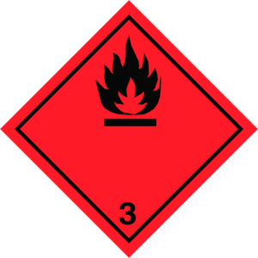

14.4. Packing group
Packing group (TDG) | : | III

14.5. Environmental hazards
Marine pollutant | : | Yes (IMDG only)  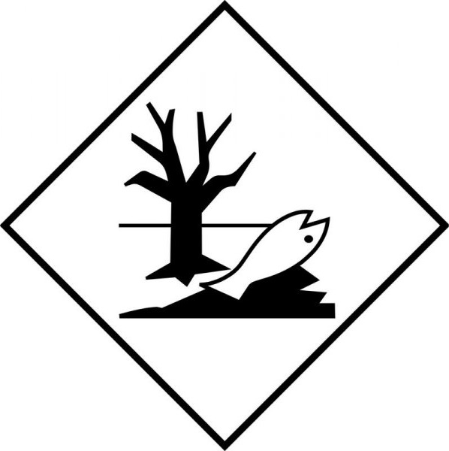
Other information | : | No supplementary information available.

14.6. Special precautions for user
Special transport precautions | : | Do not handle until all safety precautions have been read and understood.

TDG
UN-No. (TDG) | : | UN1993
TDG Special Provisions | : | 16 - (1) The technical name of at least one of the most dangerous substances that predominantly contributes to the hazard or hazards posed by the dangerous goods must be shown, in parentheses, on the shipping document following the shipping name in accordance with clause 3.5(1)(c)(ii)(A) of Part 3 (Documentation). The technical name must also be shown, in parentheses, on a small means of containment or on a tag following the shipping name in accordance with subsections 4.11(2) and (3) of Part 4 (Dangerous Goods Safety Marks).  (2) Despite subsection (1), the technical name for the following dangerous goods is not required to be shown on a shipping document or on a small means of containment when Canadian law for domestic transport or an international convention for international transport prohibits the disclosure of the technical name:  (a) UN1544, ALKALOID SALTS, SOLID, N.O.S. or ALKALOIDS, SOLID, N.O.S;  (b) UN1851, MEDICINE, LIQUID, TOXIC, N.O.S;  (c) UN3140, ALKALOID SALTS, LIQUID, N.O.S. or ALKALOIDS, LIQUID, N.O.S;  (d) UN3248, MEDICINE, LIQUID, FLAMMABLE, TOXIC, N.O.S; or  (e) UN3249, MEDICINE, SOLID, TOXIC, N.O.S.  (3) Despite subsection (1), the technical name for the following dangerous goods is not required to be shown on a small means of containment:  (a) UN2814, INFECTIOUS SUBSTANCE, AFFECTING HUMANS; or  (b) UN2900, INFECTIOUS SUBSTANCE, AFFECTING ANIMALS,150 - An approved ERAP is required for the dangerous goods referred to in paragraph 7.2(1)(f) of Part 7 (Emergency Response Assistance Plan). SOR-2019-101
Explosive Limit and Limited Quantity Index | : | 5 L
Excepted quantities (TDG) | : | E1
Passenger Carrying Road Vehicle or Passenger Carrying Railway Vehicle Index | : | 60 L

14.7. Transport in bulk according to Annex II of MARPOL 73/78 and the IBC Code
Not applicable

SECTION 15: Regulatory information

15.1. National regulations
All components of this product are listed, or excluded from listing, on the Canadian DSL (Domestic Substances List) and NDSL (Non-Domestic Substances List) inventories.

15.2. International regulations
No additional information available

SECTION 16: Other information
Issue date | : | 11/15/2021
Revision date | : | 11/15/2021

Other information | : | None.
Prepared by | : | Nexreg Compliance Inc.  www.Nexreg.com  SylBarrie Translations Ltd  www.sylbarrie.com

Disclaimer: We believe the statements, technical information and recommendations contained herein are reliable, but they are given without warranty or guarantee of any kind. The information contained in this document applies to this specific material as supplied. It may not be valid for this material if it is used in combination with any other materials. It is the user’s responsibility to satisfy oneself as to the suitability and completeness of this information for the user’s own particular use.

