1. Product and Company Identification

Product Name: Tub O' Towels® Heavy Duty Cleaner and Degreaser

Product Codes: TW24-SPR, TW28-SPR

Recommended Use: For use on most non-porous surfaces. Always test on an inconspicuous area of surface for at least 5 minutes before use.

Uses Advised Against: Not recommended for use on copper, brass, leather wood or coated-wood surfaces.

Manufacturer: FedPro Inc.
4520 Richmond Road
Cleveland, OH 44128
Phone Number: 1-800-846-9300
Email: SDS@fedpro.com

Emergency Phone Number: Call Chemtrec at 1-800-424-9300

2. Hazards Identification

GHS Classification:

Physical: | Health:
Non-Hazardous | Skin Sensitization Category 1

GHS Label Elements:

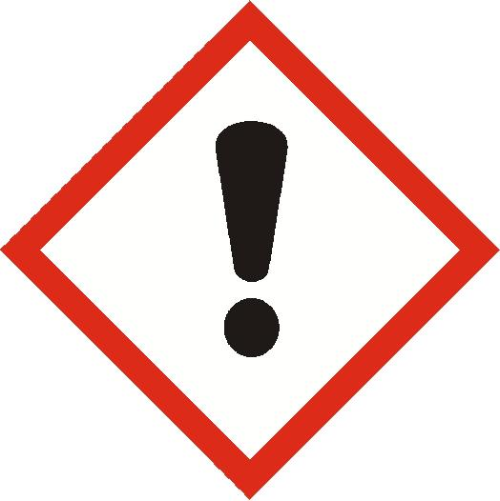

Warning!

Statements of Hazard | Precautionary Phrases
H317 May cause an allergic skin reaction | P261 Avoid breathing mist, or vapors.  P272 Contaminated work clothing must not be allowed out of the workplace.  P280 Wear protective gloves and eye protection.  P302 + P352 IF ON SKIN: Wash with plenty of soap and water.  P333 + P313 If skin irritation or rash occurs: Get medical attention.  P363 Wash contaminated clothing before reuse.  P501 Dispose of contents and container in accordance with local and national regulations.

Hazards not otherwise specified: None

3. Composition/Information on Ingredients

Component | CAS Number | Weight %
d-limonene, (R)-p-mentha-1,8-diene | 5989-27-5 | <5

The specific identity and/or exact percentage (concentration) of composition has been withheld as a trade secret.

4. First Aid Measures

Inhalation: If symptoms of exposure develop, remove to fresh air. Seek medical attention if symptoms persist.

Skin Contact: Wash with soap and water. If skin irritation or rash develops, seek medical attention.

Eye Contact: If contact occurs, flush eyes with large quantities of water for several minutes, holding the eyelids apart. If eye irritation persists, seek medical attention.

Ingestion: Not an expected route of exposure. Rinse mouth. Seek medical assistance by calling a doctor or poison center. Never give anything by mouth to a person who is unconscious or drowsy.

Most Important Symptoms: May cause eye irritation. May causes mild skin irritation. May cause an allergic skin reaction.

Indication of Immediate Medical Attention/Special Treatment: Immediate medical attention should not be required.

5. Firefighting Measures

Suitable (and Unsuitable) Extinguishing Media: Use any media that is appropriate for the surrounding fire.

Specific Hazards Arising from the Chemical: Wipes saturated with spray will burn under fire conditions after water has evaporated. Burning may release sulfur oxides, and oxides of carbon.

Special Protective Equipment and Precautions for Fire-fighters: Firefighters should wear positive pressure self-contained breathing apparatus and full protective clothing for fires in areas where chemicals are used or stored.

6: Accidental Release Measures

Personal Precautions, Protective Equipment, and Emergency Procedures: Wear appropriate protective clothing and equipment as described in Section 8.

Environmental Precautions: Report spill as required by local and national regulations.

Methods for Containment and Clean-Up: Pick up and place in a suitable container for disposal. Rinse area with water.

7. Handling and Storage

Precautions for Safe Handling: Avoid contact with eyes, skin and clothing. Use with personal protection. Wash hands after use. Wash contaminated clothing after use. Not for personal cleansing.

Conditions for Safe Storage, including any Incompatibilities: Store in a well ventilated area. Avoid overheating and freezing conditions.

8. Exposure Controls / Personal Protection

Exposure Guidelines:

CHEMICAL | EXPOSURE LIMIT
d-limonene, (R)-p-mentha-1,8-diene | None Established

Engineering Controls: General ventilation should be adequate for all normal use.

Personal Protective Equipment: None under normal use conditions.

Respiratory Protection: None under normal use conditions.

Gloves: Use good industrial hygiene practices to limit or avoid skin contact. If contact may occur, wear impervious, chemically resistant gloves.

Eye Protection: Wear safety glasses or goggles if eye contact is possible.

Other Protective Equipment/Clothing: None required under normal use conditions.

9. Physical and Chemical Properties

Appearance and Odor: Slightly yellow tinted, clear liquid with a citrus odor.

Physical State: liquid | Odor Threshold: Not available
pH: 6 - 8 (Liquid saturate) | Vapor Density: Not determined
Initial Boiling Point/Range: approximately 212°F (100°C) | Percent Volatile: Not determined
Melting/Freezing Point: approximately 32°F (0°C) | Vapor Pressure: Not determined
Solubility In Water: soluble | Evaporation Rate: Not determined
Relative Density: 1.01 at 72°F (22°C) | VOC Content: < 0.50 %
Viscosity: Not applicable | Autoignition Temp: Not determined
Coefficient Of Water/Oil Distribution: Not determined | Flammability Limits: LEL: Not determined UEL: Not determined
Flash Point: non-flammable | Flammability (solid, gas): Not applicable
Decomposition Temperature: Not determined

10. Stability and Reactivity

Reactivity: Not normally reactive
Chemical Stability: Stable under normal storage and handling conditions.
Possibility of Hazardous Reactions: None known.
Conditions to Avoid: Do not freeze.
Incompatible Materials: Acids, bases and strong oxidizing agents.
Hazardous Decomposition Products: May release sulfur oxides, and oxides of carbon.

11. Toxicological Information

POTENTIAL HEALTH EFFECTS:

Acute Hazards:

Inhalation: May cause mild irritation to mucous membranes and upper respiratory tract.

Skin Contact: May cause skin irritation. Contains d-limonene, (R)-p-mentha-1,8-diene which may cause an allergic skin reaction in sensitive individuals.

Eye Contact: May cause mild eye irritation.

Ingestion: Swallowing may cause gastrointestinal disturbances.

Chronic Effects: None currently known.

Carcinogenicity Listing: None of the components are listed as a carcinogen or potential carcinogen by IARC, NTP, or OSHA.

Acute Toxicity Values:

Calculated ATE for Product: ATE Oral: >2,000 mg/kg
ATE Skin: >5,000 mg/kg

d-limonene, (R)-p-mentha-1,8-diene:
LD50 Oral Rat: >2,000 mg/kg
LD50 Skin Rabbit: >5,000 mg/kg

12. Ecological Information

Ecotoxicity: Product is expected to be harmful to aquatic life with long lasting effects.

d-limonene, (R)-p-mentha-1,8-diene:
LC50 Pimephales promelas 688 ug/l/96 hr.
EC50 Daphnia magna 0.307 mg /l/48 hr.

Persistence and Degradability:
d-limonene, (R)-p-mentha-1,8-diene: Readily biodegradable

Bio accumulative Potential:
d-limonene, (R)-p-mentha-1,8-diene: BCF: 864.8 l/kg

Mobility in Soil: No data available

Other Adverse Effects: None.

13. Disposal Considerations

Dispose of in accordance with all local, state, and federal regulations. Offer empty containers for recycling.

14. Transport Information

DOT Hazardous Materials Description: Not Regulated

IATA Dangerous Goods Description: Not Regulated

IMDG Dangerous Goods Description: Not Regulated

15. Regulatory Information

United States:

EPA TSCA INVENTORY: All of the components of this material are listed on the Toxic Substances Control Act (TSCA) Chemical Substances Inventory.

CERCLA Section 103: This product has no RQ. Many states have more stringent release reporting requirements. Report spills required under federal, state and local regulations.

SARA Hazard Category (311/312): Classified under OSHA Hazcom 2012 GHS as per Section 2 of this SDS.

SARA 313: This product contains the following chemicals subject to Annual Release Reporting Requirements under SARA Title III, Section 313 (40 CFR 372): None

State Regulation:

California Safe Drinking Water and Toxic Enforcement Act (Proposition 65): This product does not require a California Proposition 65 warning.

16. Other Information

SDS Date of Preparation: 8/31/2023

